IT2120-PS
LabSheet10
IT24101461
EXERCISE
Part 1
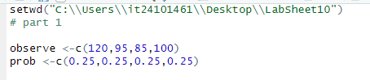
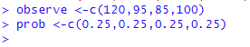
Part 2
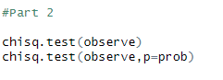
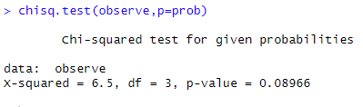
Part 3
